**Adding VLANs to the New wcdfi-share2 UCS Environment**

The new wcdfi-share2 UCS domain is managed by a Nexus 1000v switch in Layer 3 mode. This new configuration has different requirements from our current environment with regards to VLAN tagging at the UCS level and ESXi host deployment in vSphere.

**VLAN Tagging In wcdfi-share2 UCS for L3 support:**

It is critical that VLANs are tagged to the vNIC templates associated with the uplink(s) where the given VLANs are allowed . For example, tag prod VLANs only to the two prod vNIC templates, tag Repnet VLANs to the Repnet templates only, etc. Failure to follow this practice will lead to conflict and system failure. Adding a new VLAN to the new Share2 UCS involves the following steps:

1. Login in the UCSM, navigate to the LAN tab and select VLANs, Right click VLANs, and Create VLANs or simply Click on the + sign.

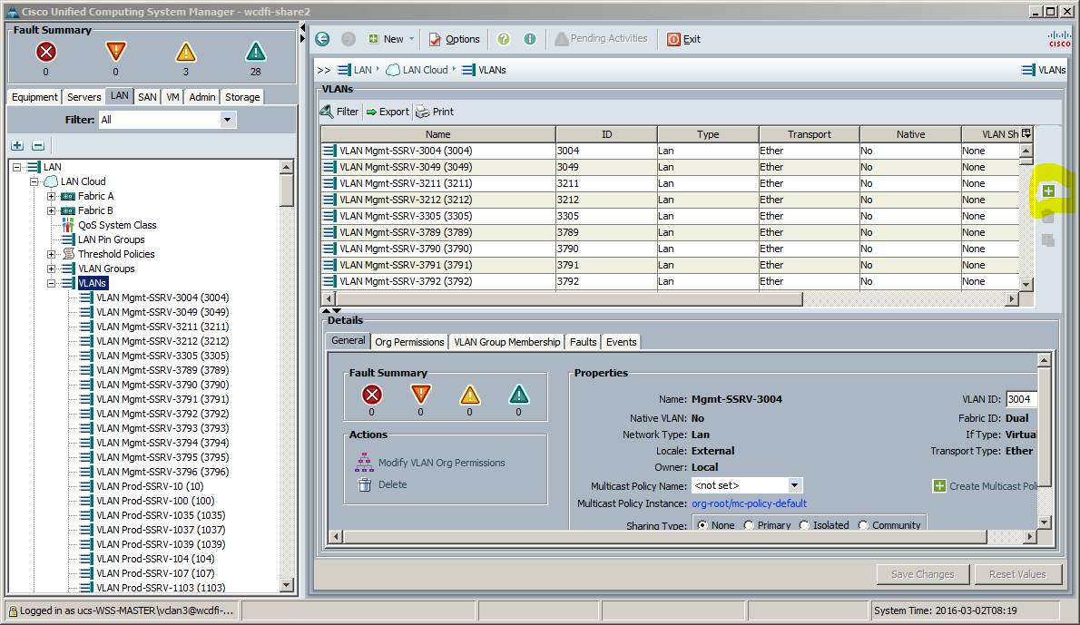

1. Add the new VLAN with the appropriate label (Prod-SSRV-VLANID, Repnet-SSRV-VLANID, etc.) See example below. Be sure to check for overlap before applying the change. If an overlap is detected, it indicates that the VLAN is already defined. DO NOT proceed with the addition and investigate.

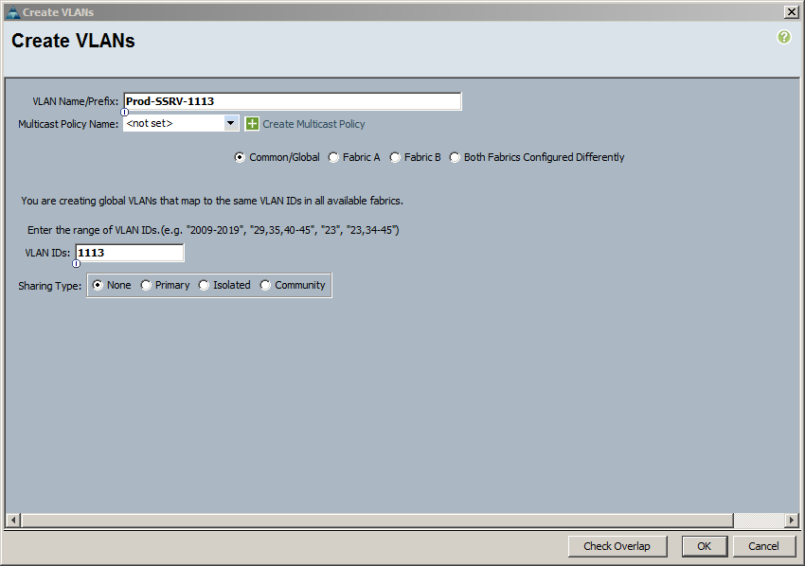

1. After the VLAN is created, navigate to the VLAN Groups and point to the VLAN group associated with the uplink for the newly added VLAN. 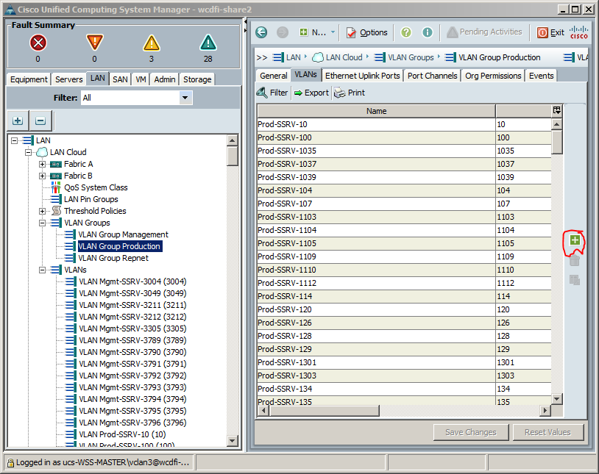
2. Click the + to add the VLAN to the VLAN Group.

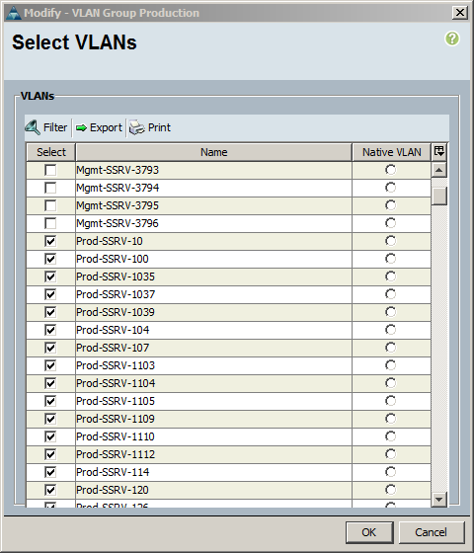

1. Select the newly added VLAN and click OK.
2. Navigate to and expand the **vNIC Templates** section and select the relevant vNIC template. In this case VNIC 4 and 5 are the vNICs associated with the prod uplinks on the A and B fabrics).

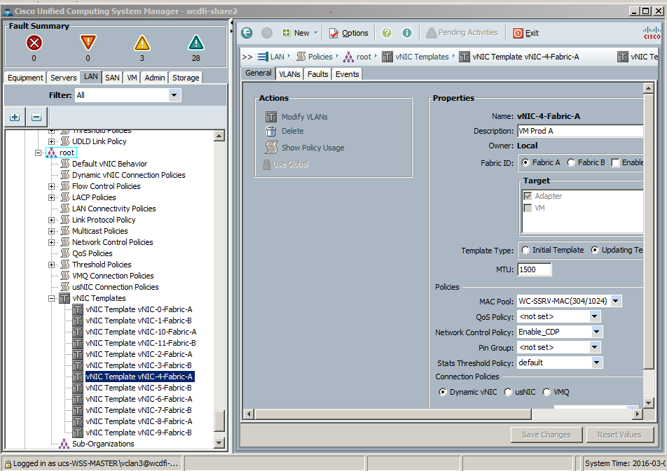

1. Point to the Fabric-A template and click Modify VLANs in the General tab. The following screen will pop up.

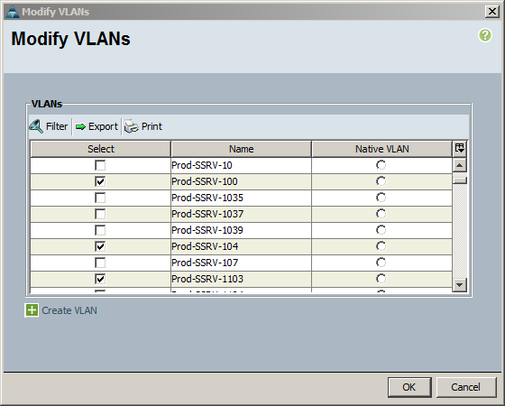

1. Select the newly added VLAN from the list and click OK.
2. Repeat the above step for the Fabric-B template.